## Phase 1: Email Server Setup

**What We're Learning**

*Brief explanation of what this phase teaches us*

**Tools Needed**

*List of software and tools for this phase*

* **hMailServer** - Our digital post office software (free and user-friendly)
* **Windows Server 2022 VM** - The building where our post office will operate
* **Your web browser** - To download hMailServer

## 📋 Step-by-Step Process

**Step 1: Prepare Your Windows Server 2022 VM**

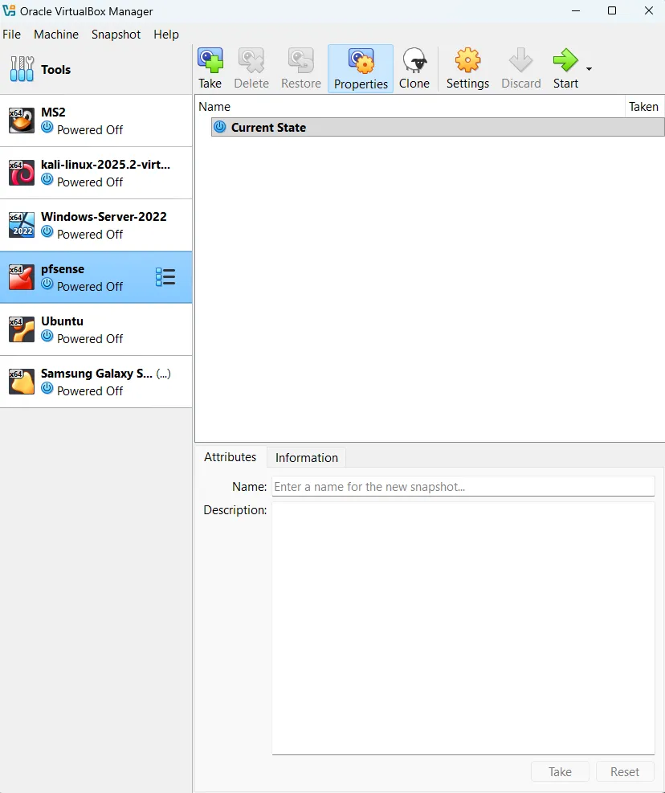

**Actions:**

1. **Start your Windows Server 2022 VM** in VirtualBox
2. **Wait for it to fully boot up** (you'll see the desktop)
3. **Open Internet Explorer or Edge browser**

**🧠 Learning Note:**

Windows Server is like a more powerful version of regular Windows, designed to run services (like our email server) for multiple users.

**Step 2: Download hMailServer**

**Actions:**

1. **Navigate to:** <https://www.hmailserver.com/download>
2. **Look for the latest version** (should be something like "hMailServer 5.6.8")
3. **Click the download link** for the full installer (not the upgrade version)
4. **Choose "Save file"** when prompted

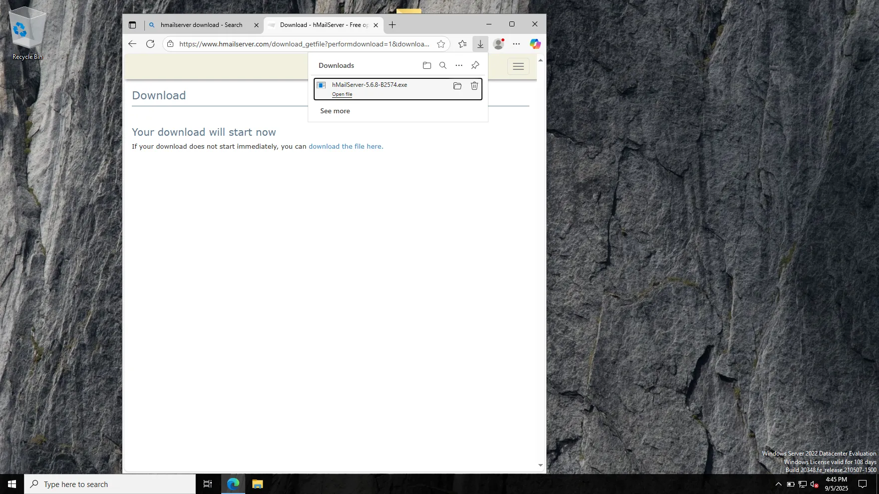

**Learning Note:**

hMailServer is like building a complete post office. It can receive mail from the outside, sort it, store it in individual mailboxes, and let people check their mail.

**Step 3: Install hMailServer**

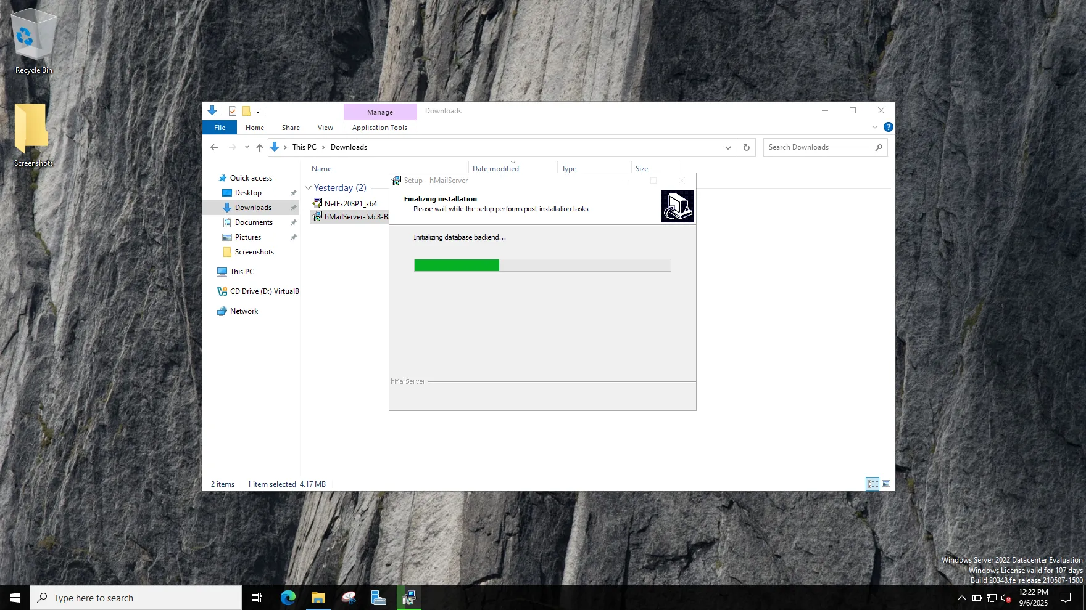

**Actions:**

1. **Double-click the downloaded hMailServer installer**
2. **Click "Next"** through the welcome screen
3. **Accept the license agreement** and click "Next"
4. **Choose installation location** (default is fine) and click "Next"
5. **Select components** - leave everything checked and click "Next"
6. **Choose "Use built-in database engine"** (this is simpler for learning)
7. **Create administrator password** - write this down! Use something like: AdminPass123
8. **Click "Install"** and wait for completion

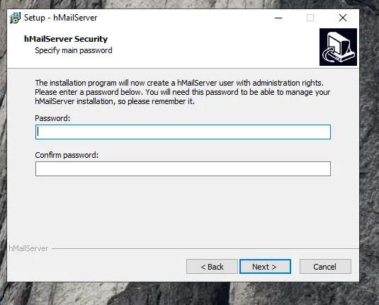

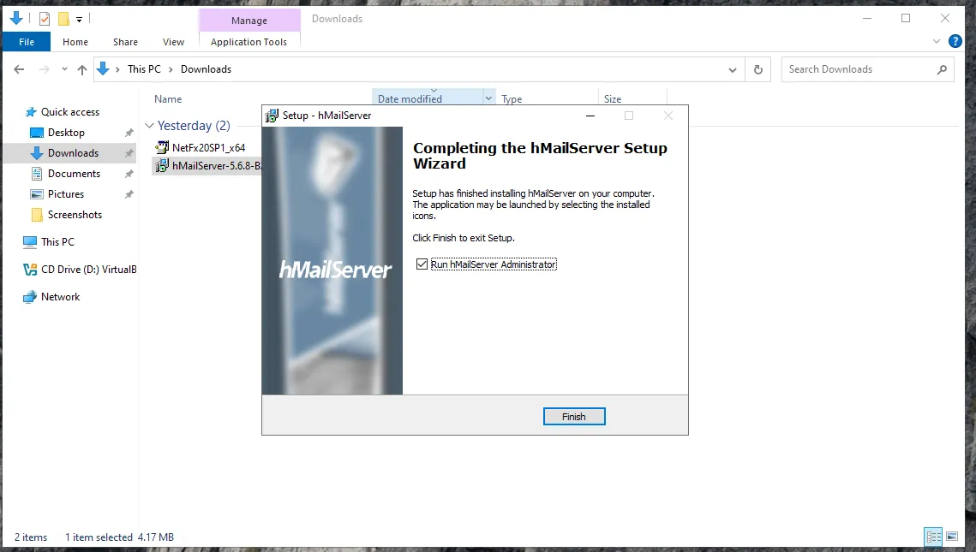

**Learning Note:**

The "built-in database" is like having a filing cabinet built into our post office to store all the mailboxes and messages, rather than using a separate storage building.

**Step 4: First Launch and Configuration**

**Actions:**

1. **Look for hMailServer Administrator** icon on desktop or Start menu
2. **Double-click to launch hMailServer Administrator**
3. **You'll see a connection dialog** - click "Connect" (it should connect to localhost automatically)
4. **Enter the administrator password** you created earlier
5. **Click OK**

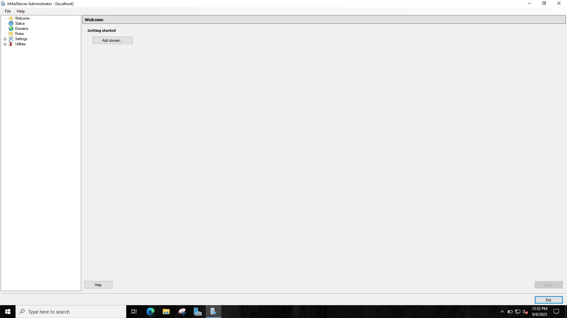

**Learning Note:**

The Administrator tool is like the post office manager's control panel - from here we can create mailboxes, set up rules, and manage our entire email system.

**Step 5: Create Your Email Domain**

**What's a Domain?**

Think of a domain like your company's address. Instead of @gmail.com or @yahoo.com, we'll create something like @ourcompany.local for our virtual company.

**Actions:**

1. **In hMailServer Administrator, look for "Domains" in the left panel**
2. **Right-click on "Domains"** and select "New Domain"
3. **Enter domain name:** ourcompany.local
4. **Click "Save"**
5. **You should see your domain appear in the list**

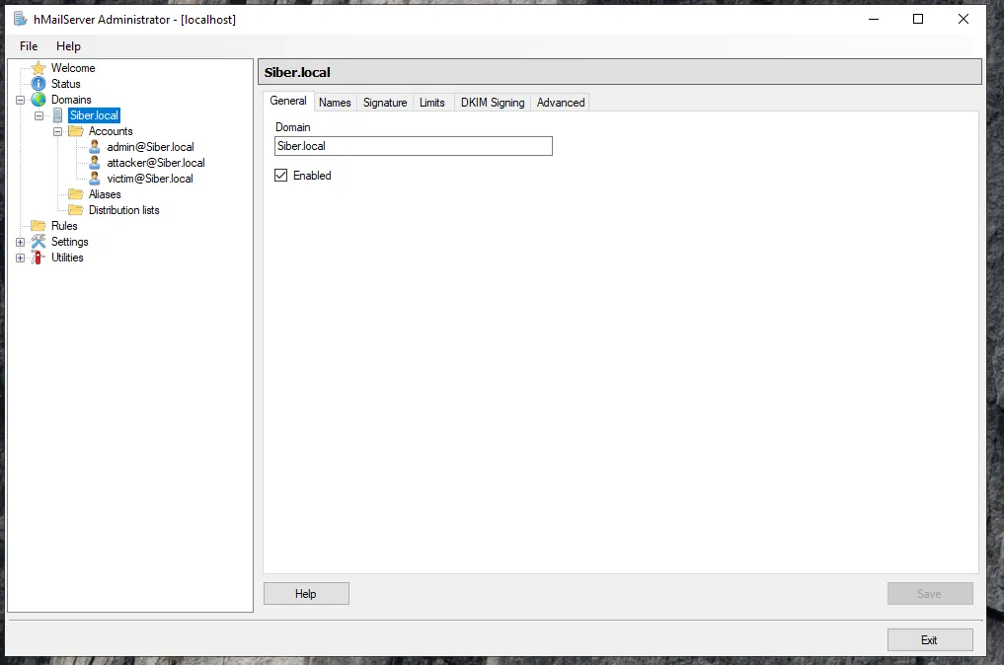

**Learning Note:**

We use ".local" because this is only for our internal network. In the real world, companies buy domains like "[company.com](http://company.com)" from domain registrars.

**Step 6: Create Email Accounts (Our First Mailboxes)**

**We'll create 3 accounts:**

* [**admin@ourcompany.local**](mailto:admin@ourcompany.local) - The administrator
* [**victim@ourcompany.local**](mailto:victim@ourcompany.local) - Our phishing target
* [**attacker@ourcompany.local**](mailto:attacker@ourcompany.local) - Our simulated hacker

**Actions for First Account:**

1. **Expand "ourcompany.local" in the left panel**
2. **Right-click on "Accounts"** and select "New Account"
3. **Enter Address:** admin@ourcompany.local
4. **Enter Password:** AdminEmail123 (write this down!)
5. **Set Maximum size:** 100 MB (default is fine)
6. **Click "Save"**

**Repeat for other accounts:**

* [**victim@ourcompany.local**](mailto:victim@ourcompany.local) with password: VictimPass123
* [**attacker@ourcompany.local**](mailto:attacker@ourcompany.local) with password: AttackerPass123

### **Learning Note:**

These accounts are like individual mailboxes in our post office. Each person gets their own secure mailbox that only they can access with their password.

✅ Success Checkpoints

**Test Steps:**

1. **In hMailServer Administrator, go to "Utilities" menu**
2. **Click "Send Test Message"**
3. **Fill in:**
   * From: admin@ourcompany.local
   * To: victim@ourcompany.local
   * Subject: Test Email - Server Working!
   * Message: This is a test to confirm our email server is working correctly.
4. **Click "Send"**

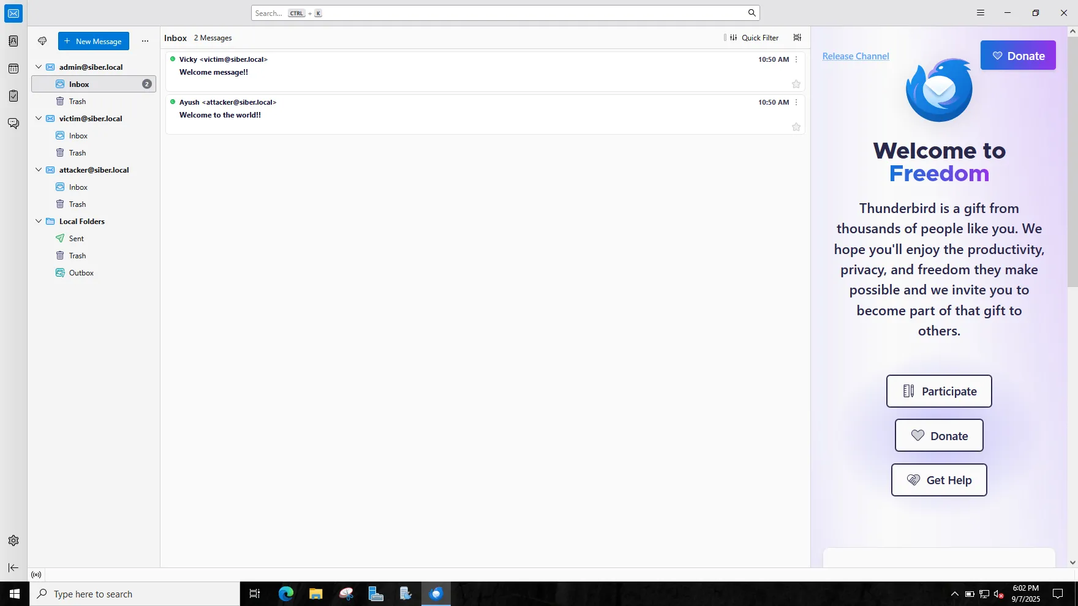

**Check if it worked:**

1. **Go to "Domains" → "ourcompany.local" → "Accounts" → "**[**victim@ourcompany.local**](mailto:victim@ourcompany.local)**"**
2. **Double-click the victim account**
3. **Look for "Messages" tab** - you should see 1 message!

**Key Concepts Learned**

*Technical terms and concepts explained simply*

* **Email Server:** The computer program that handles email delivery
* **Domain:** Like a company address (e.g., @mycompany.com)
* **Email Account:** Individual mailboxes for users
* **SMTP:** The language email servers use to talk to each other (like postal codes)
* **POP3/IMAP:** Ways to check your email (like different ways to access your mailbox)

**Problems Encountered**

*Issues faced and solutions found*

* **Problem:** Windows Server 2022 can't install .NET Framework 3.5 through Windows Features
* **Phase:** Phase 1
* **Difficulty:** Medium
* **Solution:** Use Server Manager "Add roles and features" or PowerShell Enable-WindowsOptionalFeature
* **Learning:** Legacy applications often need older frameworks installed as optional features

**Learning Note - Why This Happened:**

**Windows Server 2022 Behavior:**

* **Modern Windows Server** comes with .NET Framework 4.x pre-installed
* **Legacy .NET 2.0/3.5** needs to be added as an optional feature
* **hMailServer** was built for older .NET versions, so it needs the legacy framework

**This is Normal:**

Many older applications require legacy frameworks. This is common in IT environments!